Lawton Chiles Middle Academy
IB MYP Community Project Guide

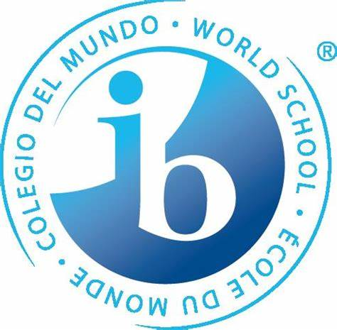

Table of contents
Mission Statement |  |  |  |  | Page 2
IB Learner Profile |  |  |  |  | Page 2
Introduction – What is the Community Project? |  |  |  |  | Page 3
Aims and Objectives of the Community Project |  |  |  |  | Page 3
Role of Teacher Supervisors |  |  |  |  | Page 4
Timeline – How do students complete the project? |  |  |  |  | Page 4
Resources and Academic Honesty |  |  |  |  | Page 6
Global Contexts |  |  |  |  | Page 6
ATL Skills |  |  |  |  | Page 7
Process Journal |  |  |  |  | Page 8
Presentation of the Community Project |  |  |  |  | Page 9
Assessment |  |  |  |  | Page 9
Glossary of Terms |  |  |  |  | Page 10
Bibliography |  |  |  |  | Page 10
Academic Honesty Form |  |  |  |  | Page 11

IB Mission Statement
IB mission statement The International Baccalaureate aims to develop inquiring, knowledgeable and caring young people who help to create a better and more peaceful world through intercultural understanding and respect. To this end the organization works with schools, governments and international organizations to develop challenging programmes of international education and rigorous assessment. These programmes encourage students across the world to become active, compassionate and lifelong learners who understand that other people, with their differences, can also be right.

Lawton Chiles Middle Academy Mission Statement
LCMA is an International Baccalaureate Middle Years Programme School which offers students opportunities to develop their potential, explore their own learning preferences, take appropriate risks, and reflect on and develop a strong sense of personal identity.

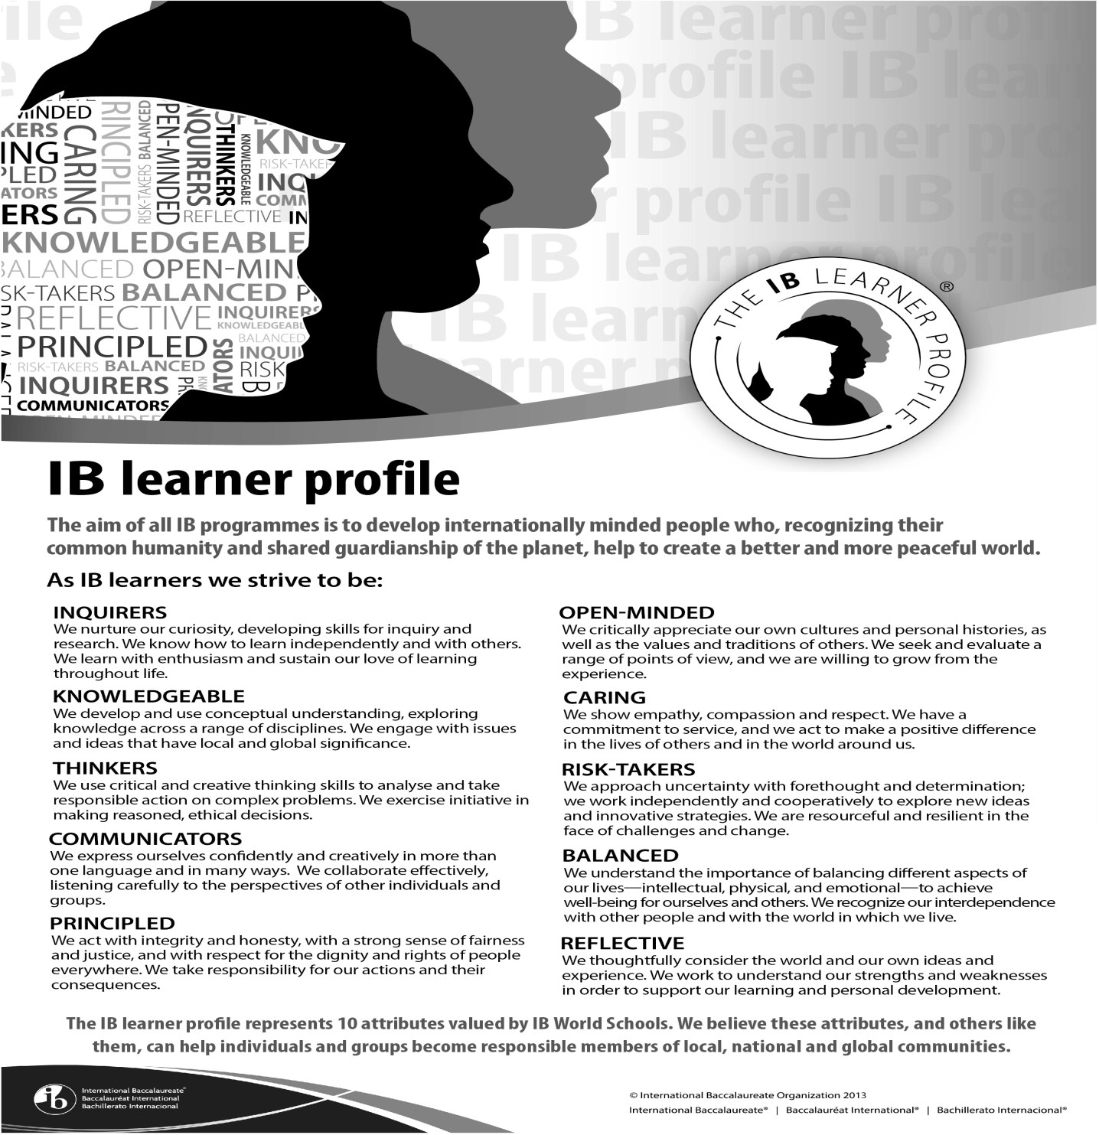
IB Learner Profile

Introduction – What is the Community Project?

The Community Project is a culminating activity for students to complete in year three (8th grade) of the MYP program at Lawton Chiles Middle Academy.

The Community Project is:
- Completed in groups of 1-3 students assigned to a teacher advisor
- Completed over an extended time period (minimum of 15 hours)
- The product of independent, student-led inquiry, research, action, and reflection
- Focused on identifying a need in a community and creating an action plan to address it
  - Dynamic action - energetic, powerful, goal-oriented
- Assessed (portion)

The Community Project is not:
- Volunteering for a specific amount of hours only
- Simple fundraising only (bucket/jar drops, pre-organized fundraising like Trick-Or-Treat- for UNICEF, crowdfunding...)
- Simple action only (posting flyers, running errands for teachers, serving in a shelter, picking up trash...)
  - Static action - stationary or fixed activities

Based on International Baccalaureate Organization (IBO) guidelines, the community project focuses on community and service, encouraging students to explore their right and responsibility to implement service as action in the community. The community project gives students an opportunity to develop awareness of needs in various communities and address those needs through service learning. As a consolidation of learning, the community project engages in a sustained, in-depth inquiry leading to service as action in the community.

Aims and Objectives of the Community Project
The aims of MYP projects are to encourage and enable students to:
- participate in a sustained, self-directed inquiry within the global context of Health & Physical Education
- generate creative new insights and develop deeper understandings through in-depth investigation
- demonstrate the skills, attitudes and knowledge required to complete a project over an extended period of time
- communicate effectively in a variety of situations
- demonstrate responsible action through, or as a result of, learning
- appreciate the process of learning and take pride in their accomplishments

The objectives of the Community Project encompass the following dimensions of knowledge. This also serves as the Assessment Criterion for the Community Project.
Objective A: Investigating
- Define a goal to address a need within a community, in the area of Physical & Health Education.
- Identify prior learning and subject-specific knowledge relevant to the project
- Demonstrate research skills
Objective B: Planning
- Develop a proposal for action to serve the need
- Plan and record the development process of the project III. Demonstrate self-management skills
Objective C: Taking action
- Demonstrate service as action as a result of the project
- Demonstrate thinking skills
III. Demonstrate communication and social skills
Objective D: Reflecting
- Evaluate the quality of the service as action against the proposal
- Reflect on how completing the project has extended their knowledge and understanding of service learning III. Reflect on their development of ATL skills

Role of Teacher Supervisors

Each student or group will be assigned to a Supervisor, a teacher whom they will report to throughout the process to guide them in meeting the assessment criteria. The Supervisor cannot assist in the completion of the project, but serve as support for the student.
The supervisors’ responsibilities are to:
- ensure the chosen MYP project topic satisfies appropriate legal and ethical standards with regard to health and safety, confidentiality, human rights, animal welfare and environmental issues
- provide guidance to students in the process and completion of the project
- confirm the authenticity of the work submitted
- assess the MYP project using the criteria in this guide
- participate in the standardization of assessment process established by the school
- provide personal project grades to the MYP coordinator
Students should receive information and guidance that includes:
- guidelines about the MYP project
- a timetable with deadlines
- the assessment criteria for the project
- advice on how to keep and use a process journal
- the importance of personal analysis and reflection
- formative feedback
- requirements for academic honesty

Timeline - How do students complete the project?
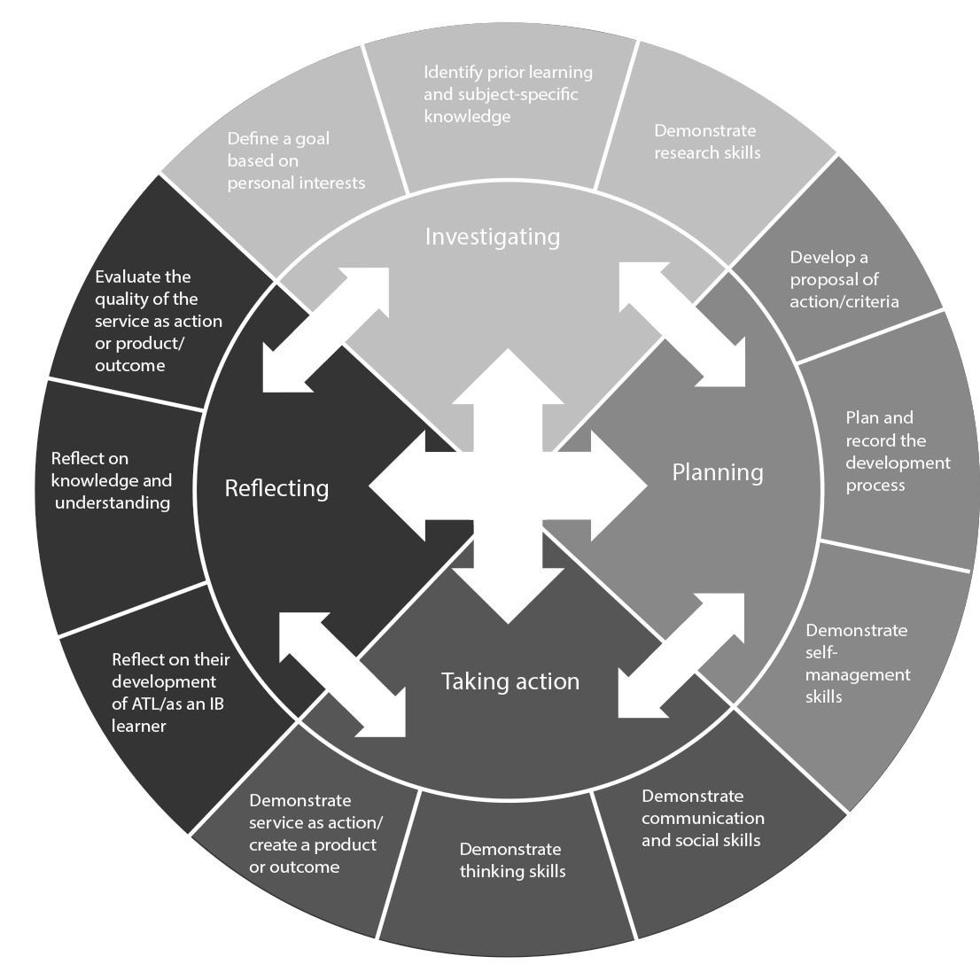

The Community Project consists of four phases (Investigating, Planning, Taking Action, Reflecting). As students can see in the IBO MYP Community Projects chart above, these four phases are all interconnected and can occur throughout the completion of the project. As a basic guideline for completing the project, students will be asked to adhere to the following timeline, though students may revisit any of these phases as needed. Students should speak with teacher advisor as needed for further information.

Phase I – Investigation
October / November 2021
- Decide on the need within the local or global community
- Determine students work group (individual or a group of up to three total members).
- Identify prior learning. What do students already know about the topic?
- Define a goal to address the need with the local or global community
- Identify the Global Context students project is related to (see Global Contexts on page 7)
- Develop students proposal for review with students advisor – This should be recorded in students Process Journal
- Meet with advisor – don't forget to get Academic Honesty form signed! (Academic Honesty located on page 13)
- Record information in students process journal

Phase II – Planning
December 2021
- Research resources and gather information
- Meet with advisor – don't forget to get Academic Honesty form signed! (Academic Honesty located on page 13)
- Record information in students process journal
- Turn in flow map and paragraph based on summer assignment. This will be submitted to the Individuals and Societies teacher and be graded using Criterion B (Investigation). Students will receive more information from their classroom teacher.

Phase III – Taking Action
January /February 2022
- Carry out the service as action
- Turn in formal letter to community experts asking for assistance or members of the community, inviting them to the Community Project Expo. Experts or invitees should have some expertise or connection to the subject of the project. The letter will be submitted to students Language and Literature teacher, as an assessment (Criterion D – Using Language under Language and Literature).
- Meet with advisor – don't forget to get Academic Honesty form signed! (Academic Honesty located on page 13)
- Record information in students process journal

Phase IV – Reflecting
March / April 2022
- Finalize students community projects as action
- Prepare students presentation for assessment/expo
- Complete students process journal (see Process Journal for details)
- Reflect on students project (see Reflection for details)
- Meet with advisor for assessment – don't forget to get the Student Declaration portion of Academic
Honesty form signed! (Academic Honesty located on page 13)

Resources and Academic Honesty

In order to maintain integrity of the project, students should select relevant and reliable information from a variety of sources to develop the Community Project. Students should select a range of sources and a variety of source types. Students should consider factors such as credibility of the author, currency, accuracy, relevance, intended audience and objectivity of the source.
During the whole process, students will keep a record of their decisions in their process journals and should use this as a resource to help them produce the project presentation or report.
Students should:
- Record information collected from sources in the Process Journal, along with annotations and possible uses
- Maintain an annotated bibliography of all print and media sources used (bibme.org or easybib.com)
- Meet with the Project Supervisor as scheduled and have the Academic Honesty form signed
- Although students are required to have the Academic Honesty Policy signed three times, the Policy should be signed as assigned in the Timeline on Page 4. If students have additional meetings with their teacher supervisor, they should add them to the process journal.
- Adhere to the Lawton Chiles Middle Academy Academic Honesty Policy and PCPS Code of Conduct regarding plagiarism

Global Contexts in Community Projects

Student projects should relate to one of the six Global Contexts. These areas serve as "lenses" through which students explore ideas, investigate connections across and between subject areas, and apply students’ knowledge to real world problems. The table below shows some examples of the use of each global context for an MYP community project.

Global context | Examples of community projects
Identities and relationships  Students will explore identity; beliefs and values; personal, physical, mental, social and spiritual health; human relationships including families, friends, communities and cultures; what it means to be human. | - Laughter therapy campaign in children’s hospital or elder care home  - Teaching yoga to elementary students while tutoring on the importance of lifetime fitness habits  - Researching the effects of cola drinks on digestion and developing a campaign to promote healthy choices available from school vending machines
Orientation in space and time  Students will explore personal histories; homes and journeys; turning points in humankind; discoveries; explorations and migrations of humankind; the relationships between and the interconnectedness of individuals and civilizations from personal, local and global perspectives. | - Joining a museum or historical society in the community to contribute to maintaining, restoring, and recovering local parks & recreation facilities  - Making a plan for wheelchair accessibility at a local facility  - Inspired by lack of facilities in the local community, seeking to improve the facilities for students by producing an article for the school magazine summarizing the problem and possible solutions
Personal and cultural expression  Students will explore the ways in which we discover and express ideas, feelings, nature, culture, beliefs and values; the ways in which | - Improving the environment in the local hospital by designing and creating a series of pictures to hang in the corridors  - Performing a theatre play to raise awareness on
we reflect on, extend and enjoy our creativity; our appreciation of the aesthetic. |  | melanoma  Promoting an intercultural understanding of dance through a dance class
Scientific and technical innovation  Students will explore the natural world and its laws; the interaction between people and the natural world; how humans use their understanding of scientific principles; the impact of scientific and technological advances on communities and environments; the impact of environments on human activity; how humans adapt environments to their needs. |  | Helping a local community make an efficient, low cost use of energy-powered devices  Developing a program to promote the use of technology devices in fitness routines  Campaigning to reduce paper use and to promote recycling  Campaigning to increase sidewalks in a community  Bike park advocacy
Globalization and sustainability  Students will explore the interconnectedness of human-made systems and communities; the relationship between local and global processes; how local experiences mediate the global; the opportunities and tensions provided by world-interconnectedness; the impact of decision-making on humankind and the environment. | •  •  • | Campaigning to raise awareness and reduce plastic straw waste use  Passing a plan to local authorities for tree planting  in an area in need of re-greening Creating a school or community garden for organic vegetables  Cooking school for healthy meals
Fairness and development  Students will explore rights and responsibilities; the relationship between communities; sharing finite resources with other people and with other living things; access to equal opportunities; peace and conflict resolution. | • | Campaigning for access to information regarding nutrition for expectant mothers.  Campaign to market the affordable fitness facilities for students in the community

Approaches to learning

During the course of the Community Project, students should consider the Approaches To Learning (ATL skills being developed or strengthened. This is part of the reflection process. The chart below relates the assessment criterion to the ATL skills being utilized in each stage of the process.
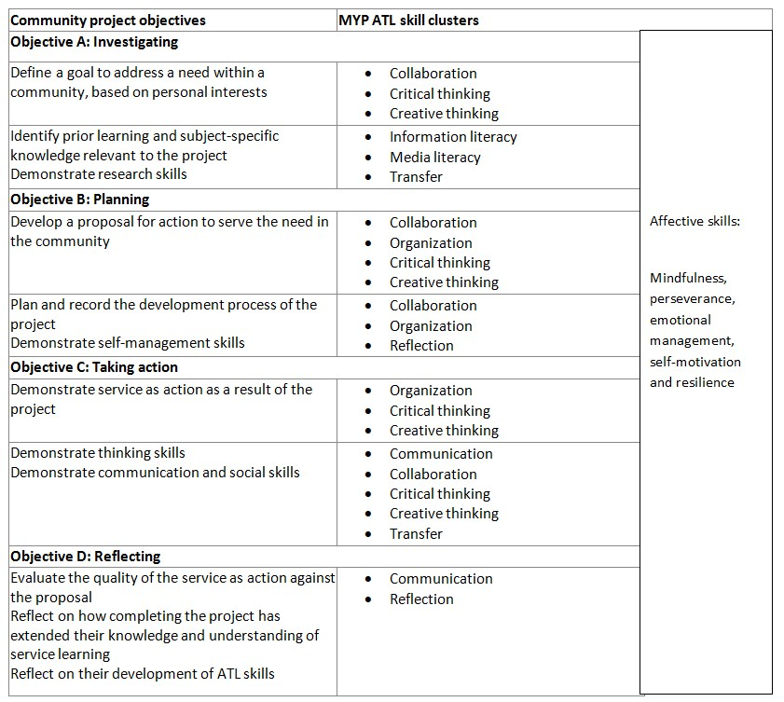

The Process Journal

Each member of the team should document their process in the process journal. The purpose of the process journal is for students to demonstrate their working behavior and maintain academic honesty.

The Process Journal is a record of progress maintained by each student throughout the project. The format of the Process Journal is determined by the individual student. Students are strongly advised to make digital copies of their journals or to transmit copies of their journals to an online storage site, as the Community Project is completed over an extended time period and paper copies can easily become lost.
The Process Journal should be reflective of all four stages of the assessment criterion.
- Students working individually should select a maximum of 10 individual extracts to represent the key developments of the project to present at the culmination of the project.
- Students choosing to work in groups on the community project will submit a maximum of 15 process journal extracts to present at the culmination of the project.

The process journal is: | The process journal is not:
- used throughout the project to document its development  - a place to record thoughts and developments, brainstorming, possible lines of inquiry and further questions raised  - a place for recording interactions with sources, for example teachers, supervisors, external contributors  - a place to record research and to maintain a bibliography  - a place for storing useful information, for example quotations, pictures, ideas, photographs  - a place for evaluating work completed  - a place for reflecting on learning  - devised by the student in a format that suits his or her needs  - a record of reflections and formative feedback received | - used on a daily basis (unless this is useful for the student)  - written up after the process has been completed  - additional work on top of the project; it is part of and supports the project  - a diary with detailed writing about what was done  - a static document with only one format.

Selecting process journal extracts – Students should carefully select evidence from their process journals to demonstrate development in all criteria. The student should select extracts that demonstrate how he or she has addressed each of the objectives, or annotate extracts to highlight this information.

An extract may include:
- visual thinking diagrams
- bulleted lists
- charts
- short paragraphs
- notes
- timelines, action plans
- annotated illustrations
- annotated research
- artifacts from inspirational visits to museums, performances, galleries
- pictures, photographs, sketches
- up to 30 seconds of visual or audio material
- screenshots of a blog or website
- self and peer assessment feedback
- segment of surveys completed by student

Presentation of the Community Project

The presentation of the project will occur twofold –

- In Quarter 4 of the school year, each community project will be presented to and assessed by the Project Supervisor along with two or more additional Project Supervisors for standardization. The final grade will be submitted to the IB Coordinator.
For an individual student presentation, the time allocated is 6–10 minutes.
For a group presentation, the time allocated is 10–14 minutes.
Q&A is not allowed before/during/after the presentation.
During this presentation, the following items should be turned in:
  - A completed academic honesty form for each student in students group (page 11)
  - The proposal for action
  - Process Journal extracts for each student (See Process Journal for more information)
    - Students working individually - maximum of 10 individual
    - Students working in groups - maximum of 15 process journal extracts each

  - Any supporting visual aids to be used during the expo
  - Bibliography/sources in MLA format (bibme.com or easybib.com)

- At the end of the school year, all project displays will appear in an expo. This is a science fair-type expo where all team members will attend to present their projects to students, staff, parents, and other community members.

Assessment

Throughout the process, students should refer to the Assessment Criterion for Community Project assessment under the Aims and Objectives portion of this guide. The following portions will be assessed throughout the process of the Community Project:

- In Semester 1 of the school year, each student will use their investigation assignment to complete an investigating graphic organizer. (Criterion B – Investigating).
- In Semester 2 of the school year, each student will complete an outline of their community project. (Criterion D – Using Language).
- In Quarter 4 of the school year, each community project will be presented to and assessed by the Project Supervisor along with two or more additional Project Supervisors for standardization. The final grade will be submitted to the IB Coordinator.

For an individual student presentation, the time allocated is 6–10 minutes.
For a group presentation, the time allocated is 10–14 minutes. The presentation does not allow time for Q&A.

Please note –
- Students completing the project individually will be assessed on their individual work in the project.
- Students working in groups will receive the same grade for each student. The opportunity to work together with other students promotes the understanding of teamwork and team achievement. In extenuating circumstances only, supervisors may award students different achievement levels for
their participation and performance in the community project, with approval from the IB Coordinator.
- Students who do not complete the Community Project will not receive the above mentioned grades and may not participate in the end of year activities.

Glossary of Community Project Terms

Terms | Definitions
Bibliography | An alphabetical list of every source used to research the project
Criteria | Specific elements the personal project product/outcome must meet to be a quality outcome, as defined by the student
Process journal | A generic term to refer to the documentation that students develop during the process of completing the MYP Community Project
Product | The end result of the student’s personal project used particularly where the project has resulted in a tangible artifact such as a sculpture, film, story or model
Reflection | A consideration of the process of completing the Community Project
Approaches to Learning (ATL) | Skills students develop that have relevance across the curriculum that help them “learn how to learn“
Global Contexts | "Lenses" through which students explore ideas, investigate connections across and between subject areas, and apply students knowledge to real world problems.

Bibliography
- "Projects Guide." Projects Guide. N.p., n.d. Web. 10 June 2015.
- "Online Curriculum Centre." Online Curriculum Centre. N.p., n.d. Web. 10 June 2015.
- "Global Contexts - Mesa Middle School." Global Contexts - Mesa Middle School. N.p., n.d. Web. 10 June 2015.
- "MYP: From Principles into Practice." MYP: From Principles into Practice. N.p., n.d. Web. 15 June 2015.
