INCLUSION POLICY
Lawton Chiles Middle Academy
Purpose
The Inclusion Policy is a working document developed by a committee of teachers, counselors, and administrators from Lawton Chiles Middle Academy (LCMA). Consistent with the standards and practices of the International Baccalaureate Middle Years Programme (IB MYP), this document provides an overview of LCMA’s beliefs and practices as they relate to the special educational needs of our students. This policy outlines the practices implemented at LCMA to ensure that all students receive meaningful and equitable access to the MYP curriculum, which aids in empowering them to exemplify academic integrity and exhibit responsiveness to our ever-changing global community.
Inclusion Beliefs
At LCMA, we believe that valuing diversity and promoting inclusivity is essential in producing resilient, respectful, and empathetic students. To value diversity means to understand and accept that every individual is unique. We see the diversity of our learning community as a positive means that can enrich inclusive learning opportunities for our students to become critical thinkers and better citizens of our world. We acknowledge that all students should have a least restrictive learning environment as possible to ensure equity to the curriculum. Inclusion is an ongoing process that aims to increase access and engagement in learning for all students by identifying and removing barriers (Learning Diversity, 2010). We view inclusion as an ever-changing development and are in a continuous process of defining, learning, acting, reflecting, and redefining our practices.
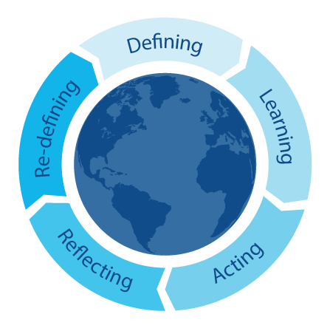

Community of learners, International Mindedness, From Principles into practice 2019
Table of Contents
Purpose | 1
Inclusion Beliefs | 1
Contents | 2
Definitions | 3
Legal Requirements | 3
LCMA Inclusion Goals & Actions | 4
Student Support Team | 7
Appendices:  A: Student Support Team Names  B: IB MYP Standards & Inclusion Practices | 9

Definitions
A 504 Plan is a plan developed to ensure that a child who has a disability identified under the law and is attending an elementary or secondary educational institution receives accommodations and support that will ensure their academic success and access to the learning environment.

An Educational Plan (EP) is a plan written for each student who is identified as eligible for gifted education services. The EP describes the student’s educational needs based on the strengths of the student and the services that will be provided to supplement and build on the basic academic state standards to ensure the student continues to make gains.

An Individualized Education Plan (IEP) is an individualized written plan developed that supports and ensures a child who has a disability identified under the law receives specialized instruction and related services.
Exceptional Students include students who need accommodations or adaptations to meet their learning needs and facilitate academic growth. These students may include, but are not limited to:
- Special Education students who have an active IEP in place
- English Language Learners who have a barrier in the language of instruction
- Students who need counseling support
- Students with medical or health issues which require a 504 plan
- High-achieving or gifted students
- Students of poverty

Federal, State, and Local Requirements
To effectively meet the needs of our special education students, we adhere to the policies and practices set forth by federal, state, and local authorities for the education of exceptional children, including:
- Implementing the accommodations and modifications specified in the Individual Education Plans (IEPs), 504 plans, and Education Plans (EPs)
- Providing accommodations, modifications and/or testing environments for students with special needs
- Scheduling students appropriately in inclusion and learning strategies classes as prescribed by IEPs and 504s
- Regularly reviewing and revising IEPS, 504s, and EPs
LCMA Inclusion Goals & Actions

Inclusion Goal | Actions to Support Goal
- Provide a positive and friendly environment to all learners with varying needs | - Model and teach others the following:  - Reinforce desired values, dispositions, and behaviors in class and around the school building  - Show empathy by understanding and sharing the feelings of others  - Learn to be aware that body language can also send messages of inclusion or exclusion  - Resolve conflict through dialogue  - Take responsibility for their own actions  - Encourage participation in learning
- Recognize and capitalize on differences and diversity  This goal connects to Affirming Identity and Building Self-Esteem, one of the four principles of good practice (Learner Diversity, 2010) | - Create a safe school environment where members of the community feel included, secure, respected, and trusted to voice their differences  - Convey diversity through the use and display of languages, images, and books  - Challenge assumptions through inquiries that honor diversity (for example, writers from diverse cultures, pioneers, inventors from a broad range of backgrounds, public figures/ representatives from local and global communities)  - Model appropriate behaviors when insensitive behaviors are observed  - Treat everyone with mutual respect, including those who speak a different language, come from a different location, or have a different learning need or belief  - Celebrate events and activities that promote intercultural appreciation, such as IB Cultural Festival (formerly Black Heritage Festival and Hispanic Festival)
- Offer meaningful and equitable access to curriculum for all students  This goal connects to Valuing Prior Knowledge, one of the four principles of good practice (Learner Diversity, 2010) | - Identify and remove barriers that impede access and engagement for all learners  - Provide opportunities for the learning community to model develop and demonstrate aspects of international-mindedness and global awareness  - Afford ongoing opportunities to discuss and reflect on cultural, linguistic, ethnic, and social diversity  - Encourage and support students to explore multiple perspectives  - Listen to other perspectives without making judgments  - Give students the opportunity to have their voice heard and share their perspective based on their background and experiences  - Infuse Approaches to Learning and the IB Learner Profile into the curriculum
- Deliver instruction through differentiated teaching methods  This goal connects to Scaffolding, one of the four principles of good practice (Learner Diversity, 2010) | - Provide professional learning opportunities around differentiation strategies to instructional staff  - Determine methods of differentiation through content, process, learning environment, and product *see graphic  - Select best differentiated methods based on group and individual needs  - Plan lessons through the use of data gleaned from assessments, backgrounds, interests, prior knowledge, and abilities to determine individual needs and provide differentiated strategies and accommodations as necessary  - Encourage independent and collective thinking among students  - Afford students the opportunities to display their learning in a variety of ways  - Teach students self-regulating strategies to assist in their learning.  - Use a variety of teaching methodologies including, but not limited to visual aids, graphic organizers, demonstrations, dramatizations, structured collaborative groups, etc.
- Monitor data for student success & needs  This goal connects to Extending Learning, one of the four principles of good practice (Learner Diversity, 2010) | - Progress monitor as appropriate  - Conduct school-wide data chats with students, teachers, and administration  - Review data regularly and intently school-wide and with teacher teams  - Adjust instruction based on group and individual needs  - Celebrate success and improvements  - Encourage independent reading  - Provide incentives for students to complete summer reading project, which includes reading a book and creating a project to promote the book for other students to read
- Communicate with stakeholders about student progress and needs through a two-way method | - Provide accurate information about the student’s needs and history  - Partner the school and family on developing approaches that will support the student’s academic development  - Host online-portfolio/data chats for students and families  - Host parent nights for students and families  - Follow through on mutual agreements  - Show respect and kindness to all community members  - Inform stakeholders of pertinent information through emails, phone calls, school website, Remind 101, Padlet, Facebook, and School Messenger

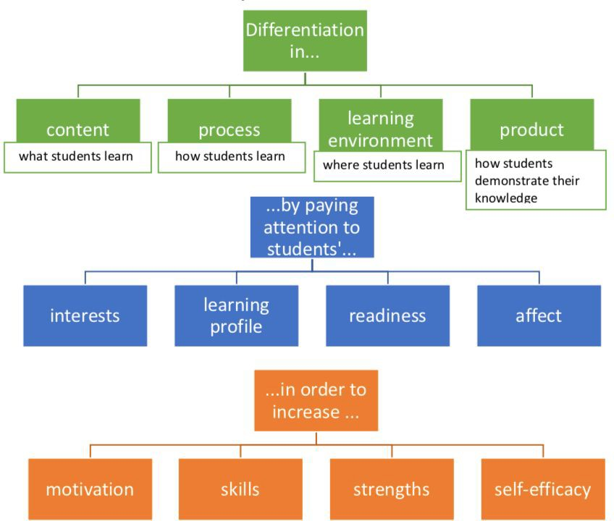

(Graphic based on Tomlinson, 2001)

Student Support Team & Roles
MENTAL HEALTH FACILITATOR
LOCAL EDUCATION AGENCY (LEA) FACILITATOR

The Student Support Team provides services to students with academic, behavioral, and social-emotional needs and supports teachers in the selection and use of appropriate strategies/interventions within the classroom. The Student Support Team discusses student academic, behavioral, and social-emotional needs through the Multi-Tiered Systems of Support process, identifying students who may need Tier 2 and/or 3 support. Administration oversees the Student Support Team. Inclusion succeeds when a school-wide culture of collaboration encourages and supports inquiry and problem-solving (MYP: Principles to Practice, 2014).
Exceptional Student Education (ESE) Teachers: ESE teachers develop, monitor IEPs, and hold annual IEP meetings. They collaboratively create goals for each exceptional student, track the progress by collecting data, and inform all necessary stakeholders of each student’s progress and continued needs. ESE teachers support students through inclusion, co-teaching, small groups, and/or individual settings. ESE teachers support General Education teachers with strategies that will benefit exceptional students in the classroom and beyond.

Gifted Resource Teachers & Teachers of the Gifted: Gifted Resource Teachers develop, monitor EPs, and hold EP meetings as necessary. They collaborative create goals for each gifted student, track the progress by collecting data, and inform all necessary stakeholders of each student’s progress and continued needs. These teachers support students through small groups and individual settings. Gifted Resource Teachers support General Education teachers with strategies that will extend learning and benefit gifted students in the classroom and beyond. These teachers research ways in which to keep gifted students engaged in the curriculum. They support them to extend their learning on their own and assist them with self-regulation strategies. Teachers of the Gifted in the Individuals and Societies department addresses the needs of our gifted students in cluster classes comprised of mostly gifted students. As the Individual and Societies teachers work with the students, they monitor each student’s progress related to individual gifted goals by maintaining documentation and sending home progress reports.

MENTAL HEALTH FACILITATOR
STUDENT SUPPORT TEAM
GENERAL EDUCATION TEACHERS
TEACHERS OF THE GIFTED
SCHOOL PSHYCHOLOGIST
ENGLISH LANGUAGE LEARNERS (ELL) PARAPROFESSIONAL
SCHOOL COUNSELORS
EXCEPTIONAL STUDENT EDUCATION (ESE) TEACHERS
General Education Teachers: The General Education Teacher is the content specialist and develops the instructional targets in conjunction with IB objectives and the Florida State Standards. The teacher collaborates with the members of the Student Support Team to plan, develop, and modify lessons based on student need. Constant communication regarding student progress is an absolute to ensure students are meeting their goals, utilizing provided accommodations, and staying the course for success.

School Counselors: The school counseling department works with students individually and/or in small groups to reach their academic, social, emotional, and/or behavioral goals. School counselors work in tandem with instructional staff to support students. Counselors guide students/parents and participate in parent-teacher-student conferences by using IB Learner Profile and Approaches to Learning language. Counselors support middle and high school transitions and manage all 504 processes and plans.

English Language Learner Paraprofessional: The ELL Paraprofessional collaborates with the instructional staff on lesson plans and modification of student tasks as well as the school counselors and testing coordinator for assessing ELL students. The ELL Paraprofessional serves as liaison between the school, teachers, and parents when there is a language barrier to communication. The ELL Paraprofessional provides push-in support for students in the classroom or in small group settings to support the achievement of their goals and academic growth.

Local Education Agency (LEA) Facilitator: The LEA Facilitator supports the ESE teachers in determining goals and strategies for exceptional students. The LEA Facilitator writes and monitors IEPS as well as hold annual IEP meetings. The LEA Facilitator supports students through inclusion, co-teaching, small groups and/or individual settings.

Mental Health Facilitator: The Mental Health Facilitator provides therapeutic services to students with specific needs. The facilitator collaborates with the school counselors and Student Support Team to help identify and provide strategies for students who may need mental health services. The facilitator communicates with school staff and parents regarding student progress and continued needs.

School Psychologist: The School Psychologist provides evaluations of students either entering the Special Education Program or as part of a student’s evaluation process. At times, the School Psychologist may provide therapeutic or mentoring services to students with specific needs.

School Social Worker: The School Social Worker provides support for students and families struggling with socioeconomic difficulties. The school Social Worker acts as a liaison to available community services. The School Social Worker also assists schools with identifying, monitoring, and aiding students with attendance/tardy needs.

Review
This policy is reviewed by LCMA stakeholders annually and revised accordingly.
Revision dates: 9/2016, 5/2019, 10/2019, 3/2020, 8/2021
Appendices

Appendix A: 2021-2022

Student Support TEam Names
STUDENT SUPPORT TEAM | Team Member Names
Exceptional Student Education (ESE) Teachers | Shelly Gerber; Moriah Brannon
Gifted Resource Teachers | Shannon Butler; Katelyn Gregory
Teachers of the Gifted | Victoria Hall; Deborah Tregler
General Education Teachers | All Core Teachers: Language & Literature, Mathematics, Sciences, and Individuals & Societies
School Counselors | Elaine Chilson; Chelsey Turner
English Language Learner (ELL) Paraprofessional | Alethea Gibson
Local Education Agency (LEA) Facilitator | TBA
Mental Health Facilitator | Rochelle Grooms
School Psychologist | Art Hughes
School Social Worker | Tammy Pope
Administration | Telay Kendrick; Angela Price

Appendix B: IB MYP Standards &
LCMA Inclusion Practices
IB MYP STANDARD | Inclusion Practice Document Location
0202-03: The school fosters the social, emotional, and physical well-being of its students and teachers. | Purpose/ Inclusion Beliefs  Inclusion Goals & Actions 1-6
0101-01: The governing body and school leaders articulate a purpose for learning that aligns with the IB’s philosophy and mission. | Purpose/ Inclusion Beliefs  Inclusion Goals & Actions 1-6
0201-03: The school organizes time for learning and teaching that provides a broad, balanced, and connected curriculum and serves the changing needs of its community. | Entire document
0202-02: The school identifies and provides appropriate learning support. | Inclusion Beliefs  Inclusion Goals & Actions 1-6  Student Support Team & Roles
0301-01: The school secures access to an IB education to the broadest possible range of students. | Purpose/ Inclusion Beliefs  Student Support Team & Roles
0301-02: The school implements, communicates and regularly reviews an inclusion policy that creates cultures that support all students to reach their full potential. | Inclusion Goals & Actions 1-6  Student Support Team & Roles  The Four Principles of Good Practice: Scaffolding
0301-05: The school implements, communicates and regularly reviews an assessment policy or policies to help create a culture of continuous learning and growth. | Inclusion Goals & Actions 2-5  The Four Principles of Good Practice: Valuing Prior Knowledge
0401-01: The school plans and implements a coherent curriculum that organizes learning and teaching within and across the years of its IB programme(s). | Student Support Team & Roles
0403-01: Teachers use inquiry, action, and reflection to develop natural curiosity in students. | Inclusion Goals & Actions 1-6  The Four Principles of Good Practice:  Extending Learning
0301-05: The school implements, communicates and regularly reviews an assessment policy or policies to help create a culture of continuous learning and growth. | Inclusion Goals & Actions 2-5  The Four Principles of Good Practice: Valuing Prior Knowledge; Scaffolding
0301-03: The school implements, communicates and regularly reviews an academic integrity policy that creates cultures of ethical academic practice. | Inclusion Beliefs  Inclusion Goals & Actions 1-6
0301-04: The school implements, communicates and regularly reviews a language policy that helps to foster intercultural understanding through communicating in a variety of ways in more than one language. | Inclusion Beliefs  Inclusion Goals & Actions 1-6  The Four Principles of Good Practice: Affirming Identity & Building Self-Esteem; Valuing Prior Knowledge; Scaffolding; Extending Learning
0401-03: The school develops, regularly reviews, and shares its curriculum in ways that explicitly engage the school community. | Inclusion Goals & Actions 1-6  The Four Principles of Good Practice: Valuing Prior Knowledge; Scaffolding; Extending Learning
0402-0: Students actively develop thinking, research, communication, social and self-management skills. | Inclusion Goals & Actions 2-5  The Four Principles of Good Practice: Valuing Prior Knowledge; Scaffolding
0404-04: Teachers promote effective relationships and purposeful collaboration to create a positive and dynamic learning community. | Inclusion Beliefs  Inclusion Goals & Actions 1-6  The Four Principles of Good Practice: Affirming Identity & Building Self-Esteem
0404-04: Students take opportunities to consolidate their learning through assessment. | Inclusion Goals & Actions 1-6  The Four Principles of Good Practice: Affirming Identity & Building Self-Esteem; Valuing Prior Knowledge; Scaffolding; Extending Learning
0404-01: Students and teachers use feedback to improve learning, teaching and assessment. | Inclusion Goals & Actions 1-6  The Four Principles of Good Practice: Affirming Identity & Building Self-Esteem; Valuing Prior Knowledge; Scaffolding; Extending Learning
0404-02: The school uses assessment methods that are varied and fit-for-purpose for the curriculum and stated learning outcomes and objectives. | Inclusion Goals & Actions 2-6  Student Support Team & Roles

